High Level design

Indoor position tracking is still an engineering challenge today. Systems today, use a variety of methods from motion capture to computer vision to track position and movement. For this system, movement tracking is achieved through RSSI or received signal strength indication. By utilizing relative RF signal strength between a user and a network of radio beacons, grid coordinates for that user can be generated.

The core of the system is broken down into “nodes”, each node consists of an Arduino Uno microcontroller connected to radio module. The functionality of the radio module is different depending on the node. There are four different types of configurations for the nodes:

* Beacon node
* Goal node
* User node
* CPU node

The current system envisioned is for half-court game types, the purposed layout can be found in figure ___

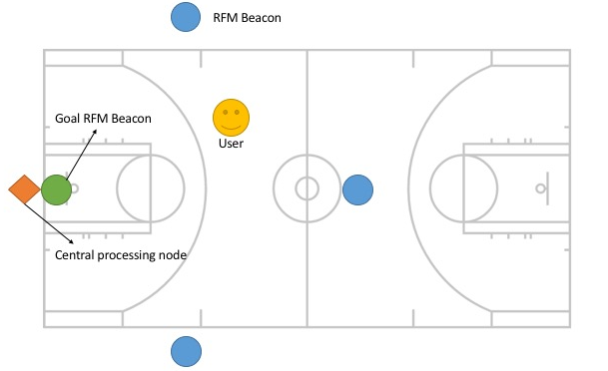

Figure___

Communication between nodes in the system is done through sending of packets. Instead of a continuous stream of data, “packets” are small 61 byte pieces of data that are sent in rapid succession to give the appearance of continuous connection. These packets will contain the signal strength information, which will be processed into grid coordinates.

The configuration of the antenna for the radio module follows a simple principle, the antenna length needs to be 1/4 of the wavelength. To achieve best results, a dipole antenna of equal length should be attached to ground, underneath the breakout module.

Each radio module is addressed by two networking parameters, network number and node number. These are numbers span from 0 to 255, giving the user 256 different network configurations in the radio module’s broadcasting range. In order for two or more devices to communicate with one another, they must share the same network number. The node number behaves much like a mac address and identifies the individual radio module. This number spans from 0 to 254, with the 255 address being a special “broadcast address.” Sending a message to this address will send it two all nodes in the network.

The user node’s functionality is to receive signal strength information from the four beacons, and report that back to the CPU node, so it can be translated into grid coordinates. These coordinates are then used by the application to assess player’s metrics and provide real time updates to the user on position. For this, the player node consists of just the radio module and the Arduino.

Similarly, the beacon node is set to broadcast, so its configuration would look similar to that of the player node.

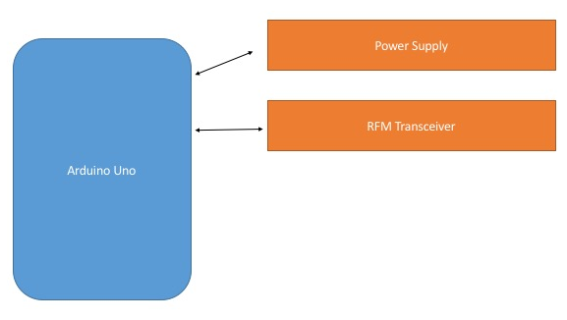

Figure___

Aside from simply broadcasting position, the goal node also has a midi speaker and a break beam sensor attached as well. This speaker shall play an indication sound, letting the player know the relative goal position. The user shall be able to access this functionality through the application. The break beam sensor is affixed to goal in such a way that the made shot trajectory triggers an event. That event is, to report back to the user the status of the shot, and record the information to the database.

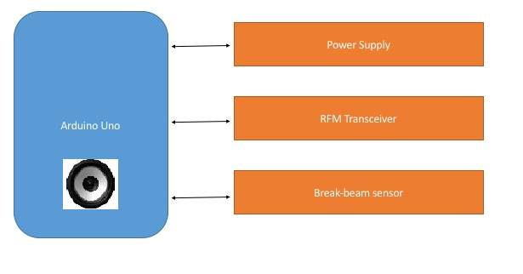

Figure___

Lastly, the CPU node, is where signal information is processed into coordinates, the database stores player information, and bridges the systems gap between microcontroller and IOS/Android application.

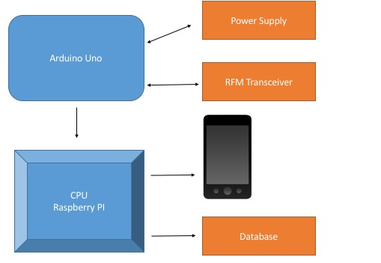

Figure__

The communication between the smartphones and the database are to be handle through Bluetooth protocol.

Wiring for node

The Uno is a 5V Arduino, and the operating range for the radio module is 0 to 3.3V. Because of the Uno’s higher operating voltage, extra care must be taken when connecting it to the radio module. This is because the higher voltage can damage the radio module. In order to correct this, a logic level converter is needed. There are 8 pins that need to be connected to power and data, they are as follows.

|  |  |
| --- | --- |
| RFM69HCW | Arduino Uno |
| O / MISO | 12 or ICSP-1 |
| I / MOSI | 11 or ICSP-4 |
| C / SCK | 13 or ICSP-3 |
| S / NSS | 10 |
| 0 / DIO0 | 2 |
| 3.3V | 3.3V |
| G / GND | GND |
| A / ANT | Refer to antenna section |

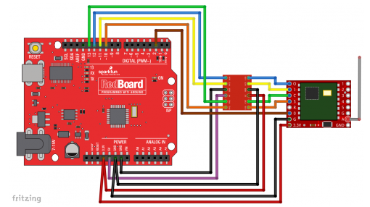

Figure ___